This document is for drafting purposes only. When you are ready to submit your application, go to <https://artswagto.submittable.com/submit/d82b4904-790d-4ae9-a478-df8c5a7cf1e1/fiscal-year-2024-2025-grants-to-organizations-application-arts-service-organizat/eligibility>

# FY24-25 GTO Application: Arts Service Organization SupportTop of Form ****Eligibility Form****

***Not sure if you fit the eligibility requirements?*** Reach out to us before beginning your application! Contact Linnea Ingalls at [*linnea.ingalls@arts.wa.gov*](mailto:linnea.ingalls@arts.wa.gov) or 360.252.9969.

**Does your organization have 501(c)(3) nonprofit status?\***

Yes

No

*To be eligible, your organization must have current state corporate nonprofit status and current federal tax-exempt determination under Section 501(c)(3) of the Internal Revenue Code.*

**Does your organization have at least 2 years of continuous operation as a nonprofit arts organization?\***

Yes

No

**Does your organization have at least two years of ongoing arts services?\***

Yes

No

**Does your organization have at least one paid staff that works 20 paid hours per week or more?\***

Yes

No

**Does your organization have a board of directors?\***

Yes

No

## **Arts Service Organization Requirements**

An Arts Service Organization (ASO) provides training, workshops, convenings, conferences, networking, technical assistance, and other professional development services to established and emerging arts professionals.

### ****Regional****art service organizations

* Provide professional development services for arts professionals from a minimum of three counties in **one** ArtsWA defined region.
* Are based in the region where services are provided.
* Have a minimum of 10% of the total public programming budget committed to professional development services for arts professionals in the region.

### ****Statewide**** art service organizations

* Primarily provide professional development opportunities, support, services, and resources to arts professionals.
* Provide services **in** ten or more counties and/or an annual convening of arts professionals from across the state. Annual convening should include structured professional development components.
* Do not perform, produce, preserve, present, or teach art.

**Does your organization provide training, workshops, convenings, conferences, networking, technical assistance, and other professional development services to established and emerging arts professionals.?\***

Yes

No

**Are you applying as a Statewide or Regional organization?\***

Statewide

Regional

**STATEWIDE: Does your organization provide services in ten or more counties and/or an annual convening of arts professionals from across the state?\***

Yes

No

*Annual convening should include structured professional development components.*

### REGIONAL: ArtsWA Regions

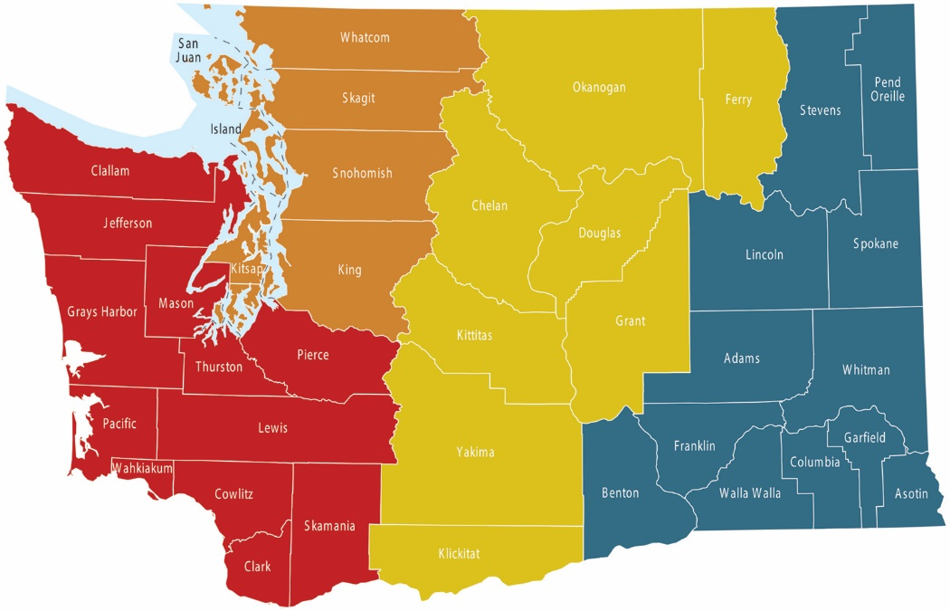

**REGIONAL: Does your organization provide professional development services for arts professionals from a minimum of three counties in one ArtsWA defined region?\***

Yes

No

**REGIONAL: Is your organization based in the region where you provide services?\***

Yes

No

**REGIONAL: Does your organization have a minimum of 10% of the total public programming budget committed to professional development services for arts professionals in the region?\***

Yes

No

Top of Form

# ****Organization Information****

**Organization Legal Name\***

Enter your organization's legal name as shown on your IRS Letter of Determination.

**Your Organization's DBA (if applicable)**

Enter your “Doing Business As” tradename if different from your organization's legal name.

You can leave this question blank if your tradename is the same as your organization's legal name.

**Organization Physical Address\***

*If your group does not have a physical address, enter the location where most of your programs take place. You will have an option to enter your mailing address later.*

**Is your organization's mailing address the same as your organization's physical address?\***

Yes, our mailing address is the same as our physical address.

No, our mailing address is different than our physical address.

## **Grant Contact Information**

Enter the contact information of the person who will manage your grant contract if awarded funds.

**Grant Contact Name\***

**Grant Contact Title\***

*For example: Director, Grantwriter, etc.*

**Grant Contact Phone\***

**Grant Contact Email\***

## **Authorizing Official**

Enter the contact information of the person who has authority to sign your grant contract if awarded funds.

**Authorizing Official Name\***

**Authorizing Official Title\***

*For example: Executive Director, Fiscal Manager, etc.*

**Authorizing Official Phone\***

**Authorizing Official Email\***

## **Organization Identifiers**

**Organization Employer Identification Number (EIN)**

**Does your organization have a Unique Entity Identifier (UEI) from SAM.gov?\***

Yes

No

I'm not sure

**Does your organization have a Statewide Vendor (SWV) number?\***

Yes

No

I don't know

*If you have received payment from Washington State in the past – you likely already have a SWV number. You can check on the status of your SWV number by using the* [*vendor number lookup*](https://gcc02.safelinks.protection.outlook.com/?url=https%3A%2F%2Fofm.wa.gov%2Fit-systems%2Faccounting-systems%2Fstatewide-vendorpayee-services%2Fstatewide-vendor-number-lookup&data=04%7C01%7Cmiguel.guillen%40arts.wa.gov%7C3fd69230bcde4efc1c4508d8c16b83c7%7C11d0e217264e400a8ba057dcc127d72d%7C0%7C0%7C637472014804358171%7CUnknown%7CTWFpbGZsb3d8eyJWIjoiMC4wLjAwMDAiLCJQIjoiV2luMzIiLCJBTiI6Ik1haWwiLCJXVCI6Mn0%3D%7C1000&sdata=t3zVW2dB4J%2B5Qck5aEADcYgW30%2BnqJl0DbhrYygORx0%3D&reserved=0) *or contacting:* [*PayeeRegistration@ofm.wa.gov.*](mailto:PayeeRegistration@ofm.wa.gov)

## **Conflict of Interest**

List any individuals involved with your organization that have an affiliation with ArtsWA. Affiliations do not preclude applications from consideration or funding.

**Does your organization have any conflicts of interest with ArtsWA?\***

Yes

No

# ****Application Questions****

## **Geographic Reach**

Below are the geographic requirements for regional and statewide arts service organizations:

**Regional**art service organizations

* Provide professional development services for arts professionals from a minimum of three counties in **one** ArtsWA defined region.
* Are based in the region where services are provided.

**Statewide** art service organizations

* Provide services in ten or more counties, **and/or** an annual convening of arts professionals from across the state. Annual convening should include structured professional development components.

**Select the WA State County where your organization's main physical address is located.\***

**Are you applying as a Statewide Arts Service Organization or a Regional Arts Service Organization?**

Statewide

Regional

**Statewide: How does your organization deliver services?**

By providing services IN ten or more counties.

By hosting an annual convening of arts professionals from across the state (this should include structured professional development components.)

**Statewide: Check all counties where your organization provide services.**

Adams

Asotin

Benton

Chelan

Clallam

Clark

Columbia

Cowlitz

Douglas

Ferry

Franklin

Garfield

Grant

Grays Harbor

Island

Jefferson

King

Kitsap

Kittitas

Klickitat

Lewis

Lincoln

Mason

Okanogan

Pacific

Pend Oreille

Pierce

San Juan

Skagit

Skamania

Snohomish

Spokane

Stevens

Thurston

Wahkiakum

Walla Walla

Whatcom

Whitman

Yakima

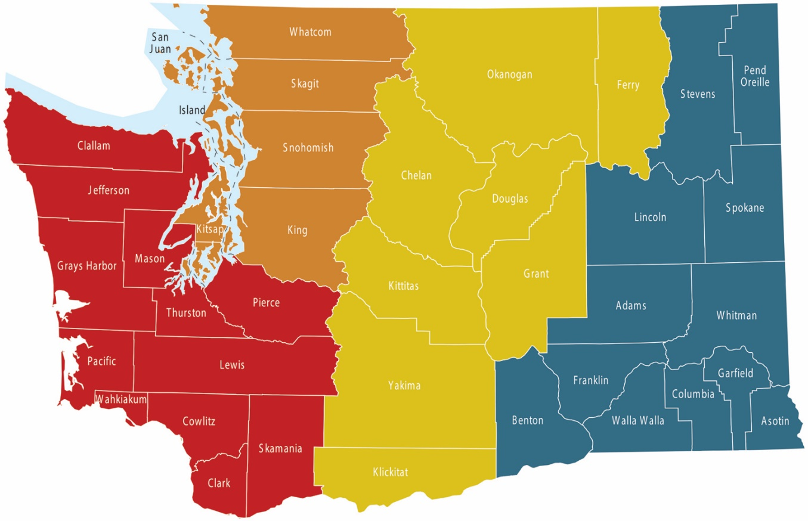

*Regional: Use this map to answer the below question.*

**Regional: Which region does your organization serve?**

Central (Yellow section)

Eastern (Blue section)

Northwest (Orange section)

Southwest (Red section)

**Central Region: Which counties does your organization serve?**

Okanogan

Ferry

Chelan

Douglas

Kittitas

Grant

Yakima

Klickitat

**Eastern Region: Which counties does your organization serve?**



Stevens

Pend Orielle

Lincoln

Spokane

Adams

Whitman

Benton

Franklin

Walla Walla

Columbia

Garfield

Asotin

**Northwest Region: Which counties does your organization serve?**

San Juan

Whatcom

Skagit

Island

Snohomish

Kitsap

King

**Southwest Region: Which counties does your organization serve?**

Clallam

Jefferson

Grays Harbor

Mason

Pacific

Thurston

Pierce

Lewis

Wahkiakum

Cowlitz

Clark

Skamania

## **Narrative**

**Mission and Strategic Plan Goals\***

Limit: 500 words

Provide your organization’s published mission statement and list the goal(s) from your organization’s strategic plan that reflect commitment to professional development of arts professionals in your region or across the state.

**Management\***

Limit: 500 words

How do you ensure the production and delivery of quality programs and services? Include financial planning, program planning, and collaborations.

**Impact\***

Limit: 500 words

How do you evaluate the impact your programs and services have on arts professionals you serve? Provide specific methodology for assessment and actions. Regional Arts Service Organizations are encouraged to describe regional need and impact.

**Inclusion\***

Limit: 500 words

Describe your strategy to include historically excluded* communities in your professional development programs. Be specific about who you reach and include.

*\*Historically excluded refers to any group of people that have historically been left out, not considered, or actively barred from opportunities and privileges by a society or organization. In the context of arts funding, governmental and private funders have historically designed grant programs for and uplifted European/European-American art for* [*able-bodied*](https://ncdj.org/style-guide/)*,* [*cis/*](https://www.transhub.org.au/101/cis)*straight groups, often in urban settings, for example.*[*Learn more about the National Endowment for the Arts' Equity Plan here.*](https://www.arts.gov/equity) *For a FAQ on Civil Rights for applicants and to ensure your organization complies,* [*click here*](https://www.arts.gov/about/civil-rights-office/applicants-recipients-of-federal-financial-assistance/what-we-do/FAQs)*.*

**Goals\***

Limit: 500 words

With regards to your professional development programs, and related to your strategic plan, list three organizational goals for the next two years that can be measured and reported on in your final report should you get a grant.

## **Budget**

**Amount you are requesting\***

You can request up to $20,000 from ArtsWA, which will be split over two years. Panelists may choose to award smaller grants to fund more organizations, so you may receive a percentage of your requested amount.

**Upload your last annual operating budget from your last completed fiscal year.\***

Acceptable file types: .csv, .doc, .docx, .odt, .pdf, .rtf, .txt, .wpd, .wpf, .gif, .jpg, .jpeg, .png, .svg, .tif, .tiff

Please upload a copy of your organization’s last completed-year operating budget.

[You may use this template here if you need.](https://www.arts.wa.gov/wp-content/uploads/2022/02/OPERATING_BUDGET_FORM_SAMPLE.xlsx)

**Upload your next fiscal year's budget.\***

Acceptable file types: .csv, .doc, .docx, .odt, .pdf, .rtf, .txt, .wpd, .wpf, .gif, .jpg, .jpeg, .png, .svg, .tif, .tiff

Please upload a copy of your organization’s next fiscal year operating budget.

[You may use this template here if you need.](https://www.arts.wa.gov/wp-content/uploads/2022/02/OPERATING_BUDGET_FORM_SAMPLE.xlsx)

## **Programs and Services**

List the professional development programs and services you provide. Include program name, short description, frequency (annual, monthly, etc.) location, estimated attendance, participation fee, and number of years providing the service.

Programs and Services

|  | A | B | C | D | E | F | G |
| --- | --- | --- | --- | --- | --- | --- | --- |
| 1 | **Title of Program or Service** | **Short Description** | **Frequency (annual, monthly, etc.)** | **Location/ Venue** | **Attendance (Estimates are acceptable)** | **Participation Fee** | **Number of years providing service** |
| 2 |  |  |  |  |  |  |  |
| 3 |  |  |  |  |  |  |  |
| 4 |  |  |  |  |  |  |  |
| 5 |  |  |  |  |  |  |  |
| 6 |  |  |  |  |  |  |  |
| 7 |  |  |  |  |  |  |  |
| 8 |  |  |  |  |  |  |  |
| 9 |  |  |  |  |  |  |  |

## **Work Samples**

Submit 3-5 work samples of your organization's past work. You may upload images, video, audio, or other documents in any combination. Website links to work samples are permitted. Video and audio work samples should not exceed 5 minutes combined.

**No more than 5 work samples will be reviewed by panelists. Panelists will not spend more than 5 minutes reviewing work samples.**

[View Work Sample Guidelines.](https://www.arts.wa.gov/wp-content/uploads/2023/01/WorkSample-Guidelines_GTO_FY24.pdf)

**How would you like to share your Work Samples?\***

File Upload

Website Link

**File Upload: Work Sample\***

Select up to 5 files to attach.

Acceptable file types: .csv, .doc, .docx, .odt, .pdf, .rtf, .txt, .wpd, .wpf, .gif, .jpg, .jpeg, .png, .svg, .tif, .tiff, .aac, .aiff, .flac, .m4a, .mp3, .ogg, .wav, .wma, .3gp, .avi, .flv, .m4v, .mkv, .mov, .mp4, .mpg, .webm, .wmv

**Link: Work Sample 1\***

Link: Work Sample 2

Link: Work Sample 3

Link: Work Sample 4

Link: Work Sample 5

**Description of linked media:\***

Limit: 200 words

Include the title(s), date(s) and location(s), and brief description of the linked media.

## **Supporting Documents**

**IRS Letter of Determination\***

Acceptable file types: .csv, .doc, .docx, .odt, .pdf, .rtf, .txt, .wpd, .wpf, .gif, .jpg, .jpeg, .png, .svg, .tif, .tiff

Upload a copy of your organization's IRS Letter of Determination. This is the document from the IRS that approves your 501(c)(3) status.

This document is required by Washington State to ensure that public funds are being used correctly.

**Board of directors and staff\***

Acceptable file types: .csv, .doc, .docx, .odt, .pdf, .rtf, .txt, .wpd, .wpf, .gif, .jpg, .jpeg, .png, .svg, .tif, .tiff

Upload a list of your organization’s board of directors and active staff. Include position titles and number of hours worked per week per position.

**Strategic Plan\***

Acceptable file types: .csv, .doc, .docx, .odt, .pdf, .rtf, .txt, .wpd, .wpf, .gif, .jpg, .jpeg, .png, .svg, .tif, .tiff

Upload your organization's most recent board approved strategic plan.

### You're done!

All that's left is pressing "submit" below. You can also save your draft and come back later.

After you hit submit, **make sure you receive a confirmation email from**[notifications@email.submittable.com](mailto:notifications@email.submittable.com)**.**We recommend putting this email on your "safe sender" list. If you aren't sure whether your application was successfully submitted, you can email Ashley Marshall at [ashley.marshall@arts.wa.gov](mailto:ashley.marshall@arts.wa.gov).

Thank you for your application!

Bottom of Form