Conservation Consultation Form

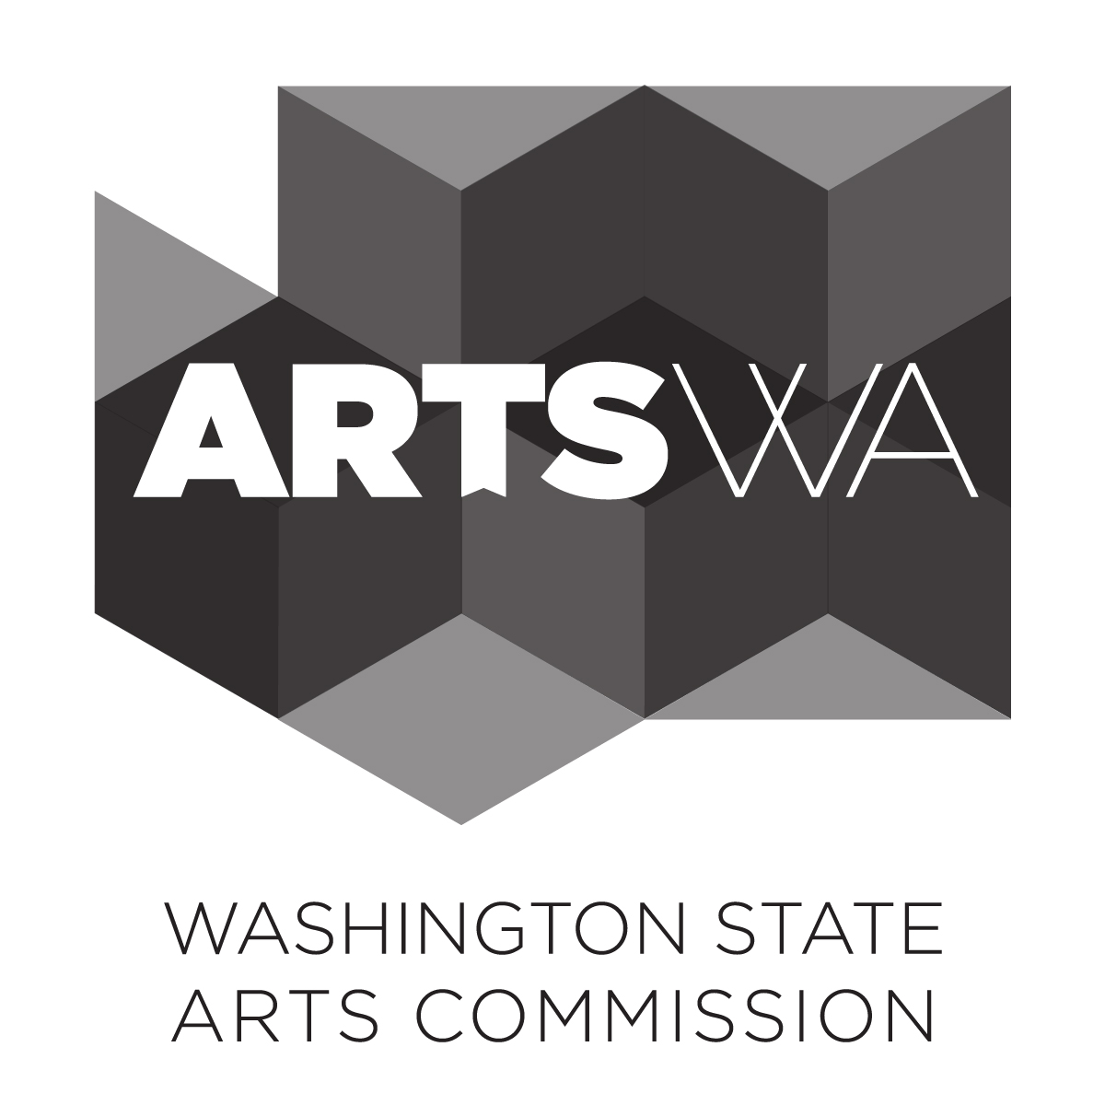

Overview
Artist: (enter name)
Site/Agency: (enter name)
Conservation Specialist: (enter your name)
ArtsWA Project Manager: (enter name)
Date: (enter date)

Conservation Consultation is an opportunity for the artist to consult with a conservator in the early stages of proposal development. We estimate that you will spend about one hour reviewing the artist’s materials, an hour meeting with the artist (usually by phone), and an hour summarizing your meeting. The ArtsWA Project Manager should have provided the following documentation to you to get the consultation underway:

The artist’s concept
Artwork location description and/or site plan or photographs of the site (if existing)
Materials under consideration
General fabrication methods
Possible protective finishes
Reversible installation methods
Artwork budget for which you are designing
Imagery (drawings, sketches, any visual representation), where relevant to consultation
Other: (enter description text)

Consultation discussion
This meeting should be used to discuss ways to accomplish the artist’s proposal and how choices—as well as the environmental and social factors at the site—may impact the short- and long-term condition of the artwork. You may also be able to help the artist determine if the concept is feasible within the budget.

Use this form to guide your consultation with the artist(s) and ensure that all critical issues are discussed. Please do not relay the information word-for-word; we prefer you use your professional judgment to paraphrase key points.

Hint: use arrows or tab key to scroll through the fill-in fields, and return key to start new paragraphs.

Location/Environment
Consider and discuss issues related to the artist’s proposed location. Consider issues that arise from interior or exterior siting; suspended or ground level placement; and access/interaction by the general public (touching, climbing, food flinging, basketballs, etc.). Summarize your discussion and any recommendations shared with the artist in the field below.

Your Comments Here

Materials
Consider and discuss the artist’s primary potential materials. Include non-primary materials if they are not appropriate for use. Be sure to consider any mechanical, technological, or equipment necessary to the function of the artwork. Summarize your discussion and any recommendations made to the artists in the field below.

Your Comments Here

Structure/Fabrication
Consider and discuss the fabrication and installation techniques proposed. Summarize your discussion and any recommendations shared with the artist in the field below.

Your Comments Here

Maintenance/Conservation
Consider and discuss anticipated maintenance needs over the life of the artwork. Be sure to consider how the artwork would be accessed and/or removed for maintenance or conservation activities. Summarize your discussion and any recommendations shared with the artist in the field below.

Your Comments Here

Additional Comments
Provide additional comments in this section.

Your Comments Here

ArtsWA Comments
Follow-up review and comments from ArtsWA staff:

For Agency Use Only

