**Working Washington Grants: Round 5 Social media**

Download these graphics, and upload them to your Facebook, Instagram and Twitter pages as posts along with the captions below.

**General: arts, heritage, science sectors**

**Facebook/Instagram/LinkedIn:**

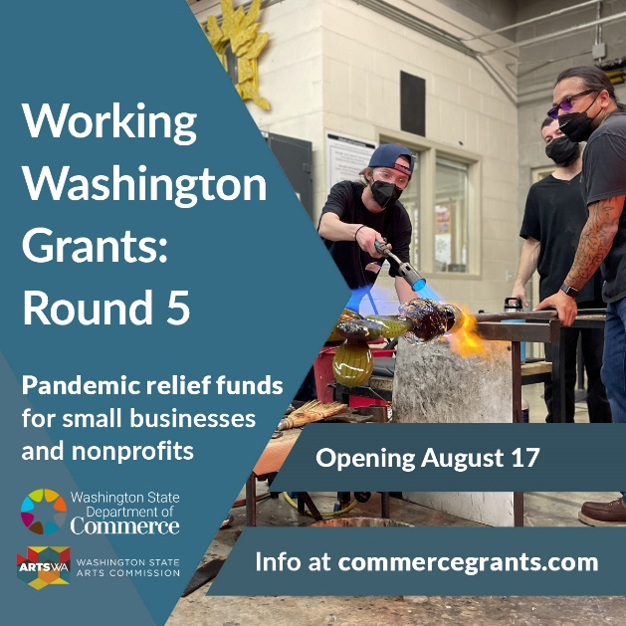

The Washington State Legislature set aside $70 million for Working Washington Grants: Round 5. Portions of the available funds are set aside for specific sectors. 60% will go to the arts, heritage, and science sectors, including live entertainment venues.

The grant will open August 17. We strongly encourage small businesses and non-profits, including sole proprietors and independent artists, to apply.

✔️ Learn more and get ready to apply: commercegrants.com

✉️ Sign up for updates: bit.ly/wwr5updates

#workingwashingtonround5 #washingtongrants #artsfunding #workingwashington #washingtonstate

**Twitter:**

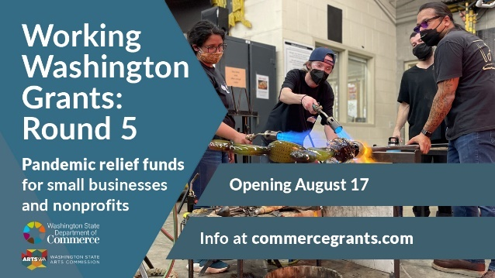@WAStateCommerce will award grants to small businesses & nonprofits this summer. 60% of available funds will go to arts, heritage, and science sectors, including live entertainment venues.

✔️ Get ready to apply: https://commercegrants.com/

✉️ Get updates: bit.ly/wwr5updates

**General: other sectors**

**Facebook/Instagram/LinkedIn:**

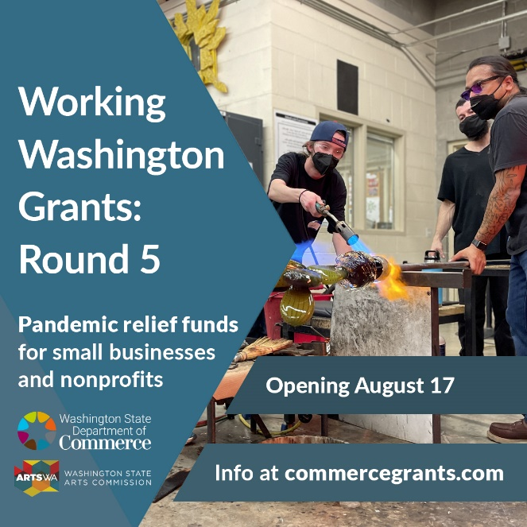The Washington State Legislature set aside $70 million for Working Washington Grants: Round 5. Portions of the available funds are set aside for specific sectors. 40% will go to most sectors, including hospitality, fitness, and personal services.

The grant will open August 17. We strongly encourage small businesses and non-profits, including sole proprietors and independent artists, to apply.

✔️ Learn more and get ready to apply: commercegrants.com

✉️ Sign up for updates: bit.ly/wwr5updates

#workingwashingtonround5 #washingtongrants #artsfunding #workingwashington #washingtonstate

**Twitter:**

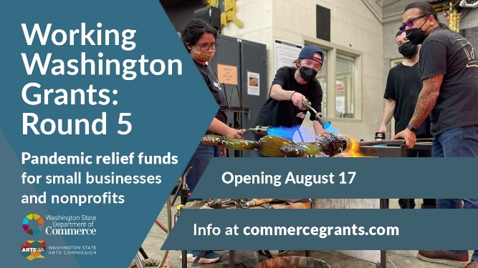@WAStateCommerce will award grants to small businesses and nonprofits this summer. 40% of available funds will go to most sectors, including hospitality, fitness, and personal services.

✔️ Get ready to apply: https://commercegrants.com/

✉️ Get updates: bit.ly/wwr5updates

**General: all sectors**

**Facebook/Instagram/LinkedIn:**

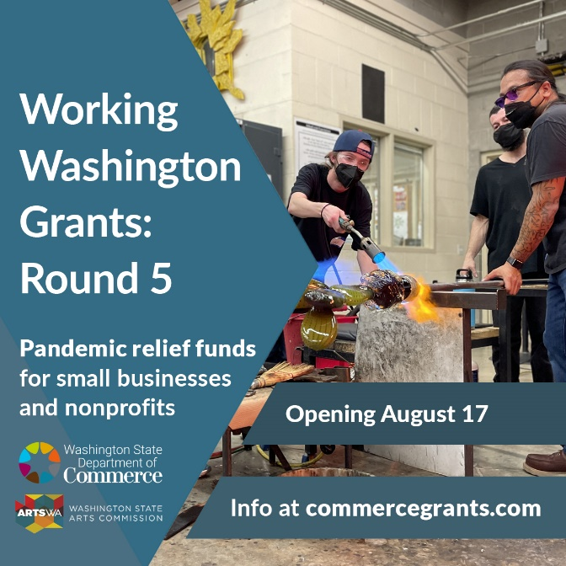The Washington State Legislature set aside $70 million for Working Washington Grants: Round 5. Portions of the available funds are set aside for specific sectors. 60% will go to the arts, heritage, and science sectors, including live entertainment venues. 40% will go to most other sectors, including hospitality, fitness, and personal services.

The grant will open August 17. We strongly encourage small businesses and non-profits, including sole proprietors and independent artists, to apply.

✔️ Learn more and get ready to apply: commercegrants.com

✉️ Sign up for updates: bit.ly/wwr5updates

#workingwashingtonround5 #washingtongrants #artsfunding #workingwashington #washingtonstate

**Twitter:**

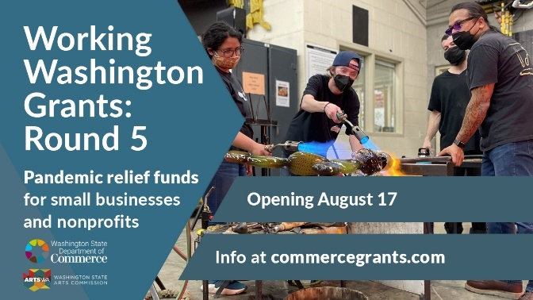The Washington State Legislature set aside $70m for Working Washington Grants: Round 5. Portions of available funds are set aside for specific sectors. Applications open on August 17.

✔️ Get ready to apply: https://commercegrants.com/

✉️ Get updates: bit.ly/wwr5updates

**Eligibility**

**Facebook/Instagram/LinkedIn:**

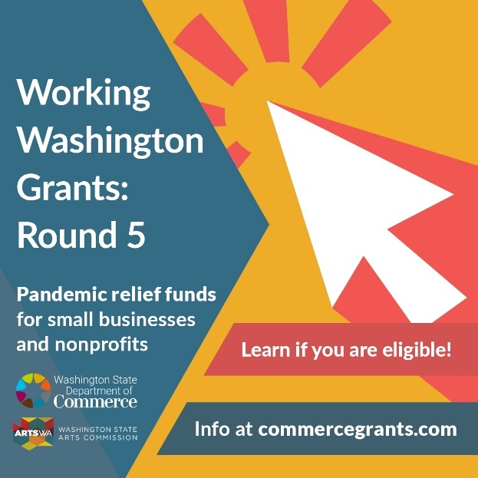💡 Are you eligible for funding from Working Washington Grants: Round 5? Check the list! You might be eligible to apply if you:

• did not report more than $5,000,000 in income in 2019

• have a UBI, EIN, or UEI number

• can show financial hardship because of the pandemic

✔️ Review eligibility and get ready to apply: commercegrants.com

✉️ Sign up for updates: bit.ly/wwr5updates

#WorkingWashingtonRound5 will open August 17.

#workingwashingtonround5 #washingtongrants #artsfunding #workingwashington #washingtonstate

**Twitter:**

💡 Are you eligible for funding from Working Washington Grants: Round 5? Review eligibility and get ready to apply: https://commercegrants.com/

✉️ Get updates: bit.ly/wwr5updates

#WorkingWashingtonRound5 will open August 17.

#washingtongrants #artsfunding #washingtonstate

**Email updates**

**Facebook/Instagram/LinkedIn:**

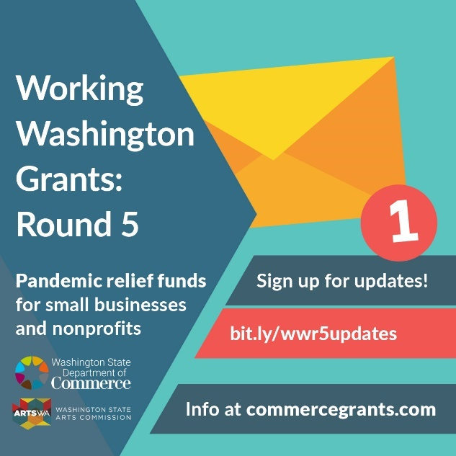💡 Stay updated on the Working Washington Grants: Round 5 program by signing up for email updates. You will get the latest info—on eligibility, how to apply, and more—delivered straight to your inbox!

✉️ Sign up for updates: https://bit.ly/wwr5updates

✔️ Get ready to apply: commercegrants.com

#WorkingWashingtonRound5 will open August 17.

#workingwashingtonround5 #washingtongrants #artsfunding #workingwashington #washingtonstate

**Twitter:**

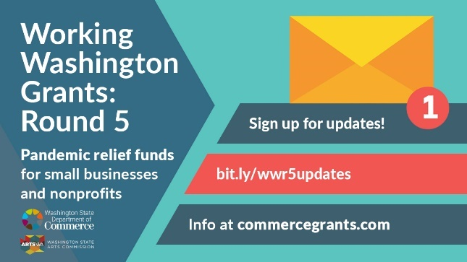💡 Stay updated on the Working Washington Grants: Round 5 program with email updates. You will get the latest info—eligibility, how to apply, and more—sent straight to your inbox!

✉️ Get updates: https://bit.ly/wwr5updates

✔️ Get ready to apply: <https://commercegrants.com/>

**UEI**

**Facebook/Instagram/LinkedIn:**

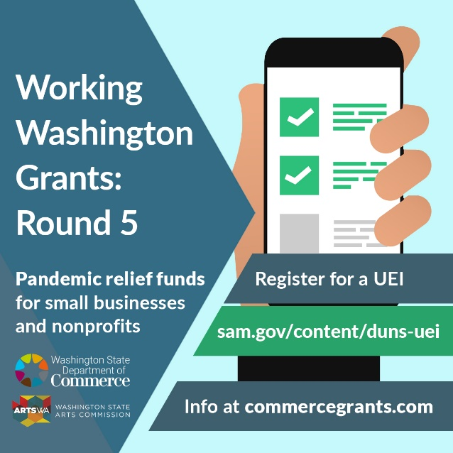⚠️ As of April 2022, recipients of grants using federal funds must have a UEI. The UEI replaces the DUNS Number. If you don’t have a UEI yet, we strongly encourage you to apply now. You must provide a UEI to get funds from Working Washington Grants: Round 5.

✔️ Register for a UEI: sam.gov/content/duns-uei

👉🏽 Learn more: commercegrants.com/uei-frequently-asked-questions

What is a UEI?

The UEI is a Unique Entity Identifier. It is a 12-digit alphanumeric number that the federal government uses to identify your business or organization. You need a UEI to get federal funds. This includes grants funded by federal programs, such as Working Washington.

#workingwashingtonround5 #washingtongrants #artsfunding #workingwashington #washingtonstate

**Twitter:**

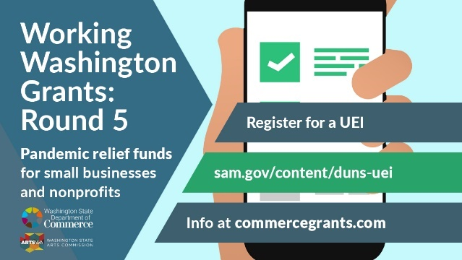⚠️ #WorkingWashingtonRound5 applicants: You must have a UEI to receive grants that use federal funds. If you do not have one, you can apply now. You cannot receive funds until you have a UEI.

✔️ Register for a UEI: sam.gov/content/duns-uei

👉🏽 Learn more: commercegrants.com/uei-frequently-asked-questions

**Deadline**

**Facebook/Instagram/LinkedIn:**

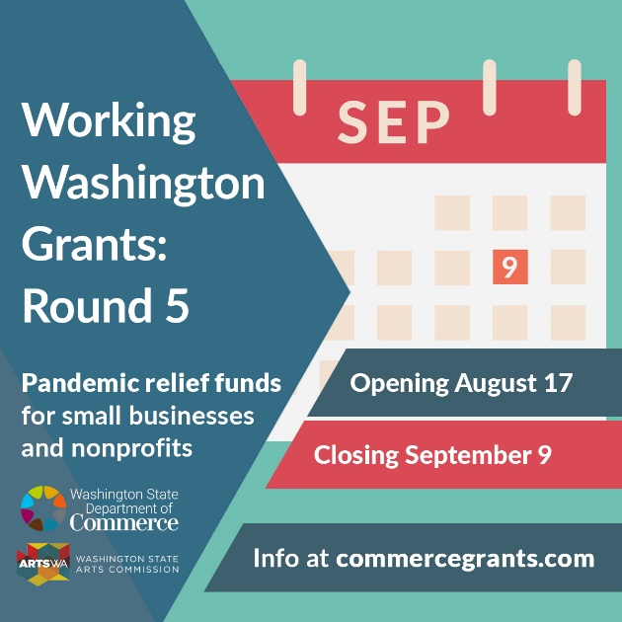

📆 Applications for Working Washington Grants: Round 5 are due on September 9 at 5:00 p.m. PST. Mark your calendar to make sure you submit your application by the due date.

✔️ Learn more and get ready to apply: commercegrants.com

✉️ Sign up for updates: bit.ly/wwr5updates

#WorkingWashingtonRound5 will open August 17.

#workingwashingtonround5 #washingtongrants #artsfunding #workingwashington #washingtonstate

**Twitter:**

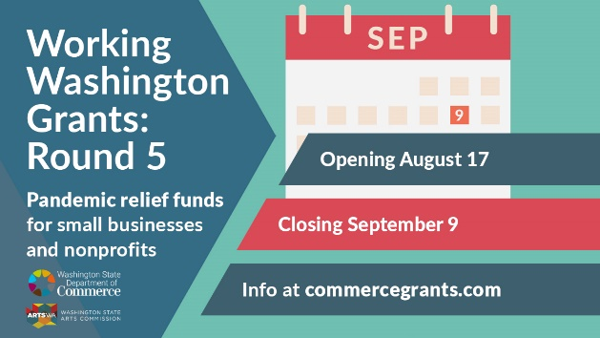 📆 Applications for Working Washington Grants: Round 5 are due on September 9 at 5pm. PST. Mark your calendar!

✔️ Get ready to apply: commercegrants.com

✉️ Get updates: bit.ly/wwr5updates

#WorkingWashingtonRound5 will open August 17.