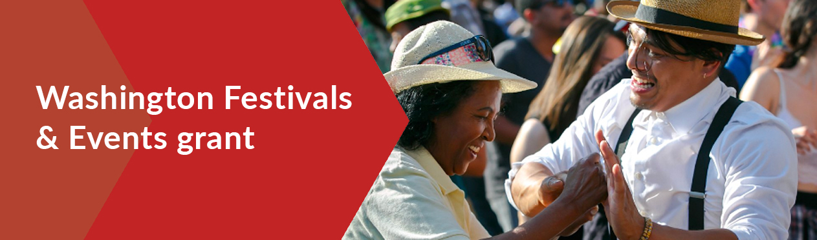
Social media and newsletter toolkit
Sample newsletter blurb:
Washington Festival and Events Association, in partnership with ArtsWA and the Washington State Department of Commerce, is now offering a Festival and Events Grant Program. It will award $3.5 million in grants. Awards range from $5,000 to $35,000. The program supports festivals and events that have been held for five or more years in communities of less than 100,000 residents. Learn more and apply at arts.wa.gov/wfea, and click here to sign up for email updates.
Sample Facebook post:
📣 Now open: the Washington Festivals & Events grant! Eligible organizations may qualify for grants ranging from $5,000 to $35,000. Funding supports festivals and events that have been held for five or more years in communities of less than 100,000 residents.
📆 Apply by July 1, 2022
👉🏽 Learn more and apply: arts.wa.gov/wfea
Sample Tweet:
📣 Now open: the Washington Festivals & Events grant! Eligible orgs may qualify for grants ranging from $5K to $35K. Funding supports festivals & events that have been held for 5+ years in communities of less than 100K residents.
📆 Apply by 7/1
👉🏽 Apply: arts.wa.gov/wfea
Contact info to share:
Questions? Please contact Bruce Skinner, Executive Director, WFEA:
☎ | 360-441-7190
✉︎ | bruce@wfea.org

Links:
ArtsWA: https://www.arts.wa.gov/wfea/
Department of Commerce: https://commercegrants.com/
Washington Festivals & Events Association: https://www.wfea.org/

